Assignment08

Windows Navigation Diagram

Football Club Management

Group-20

Kazi Ehsanul Mubin

ID-18101391

Umma Tania Arafin

ID- 18201203

CSE471 Lab Project

Section 02

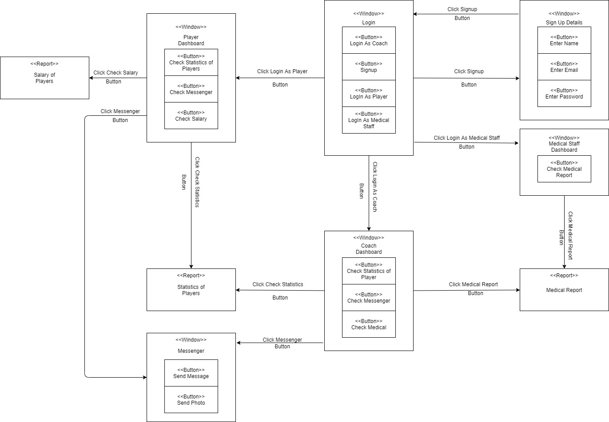Windows Navigation Diagram